**OOP - Lab Task#3**

**Name: Saad Ahmad Roll number: 20P-0051**

QNo.01: Problem (Statement)

Develop a calculator, which is able to handle two numbers. The calculator can perform addition, subtraction, multiplication, and division.

QNo.01: Problem (Analysis)

❖ Ask the user to enter two numbers

❖ Then ask to enter the operator (+, -, /, *)

❖ Calculate the result

❖ Display the result

Note: use if else-if else statement for solving this problem.

**Code:**

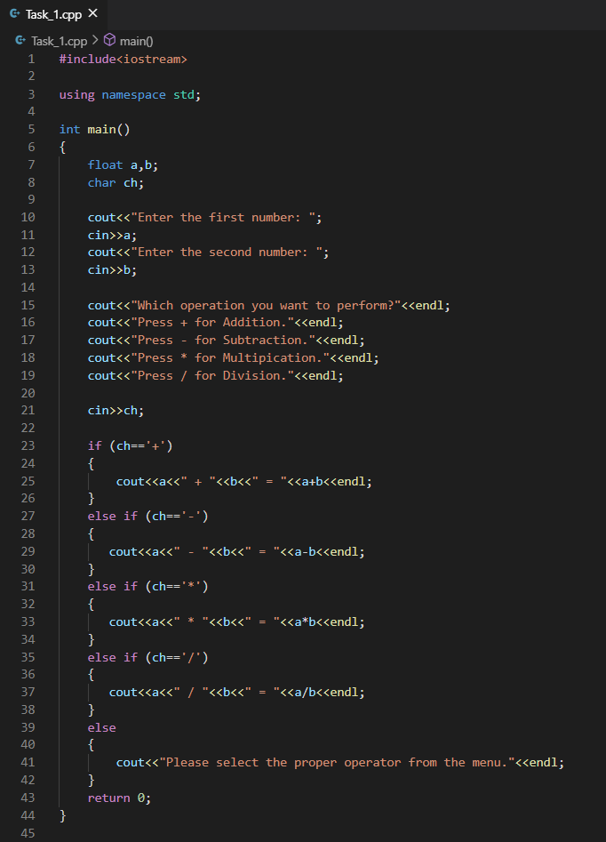

**Output:**

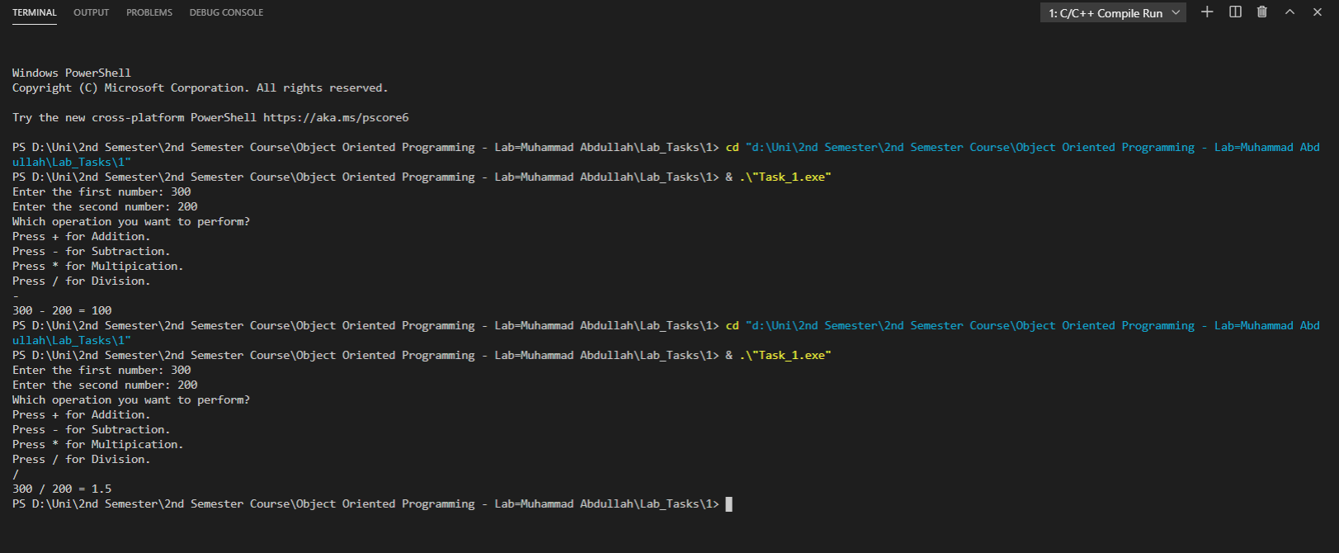

QNo.02: Problem (Statement)

Develop a calculator, which is able to handle two numbers. The calculator can perform addition, subtraction, multiplication, and division.

QNo.02: Problem (Analysis)

❖ Ask the user to enter two numbers

❖ Then ask to enter the operator (+, -, /, *)

❖ Calculate the result

❖ Display the result

Note: use switch statement for solving this problem.

**Code:**

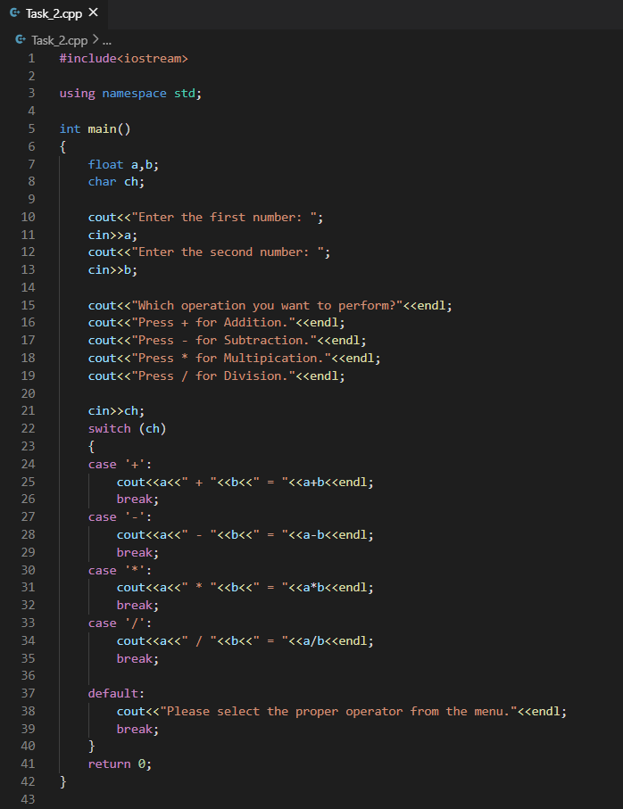

**Output:**

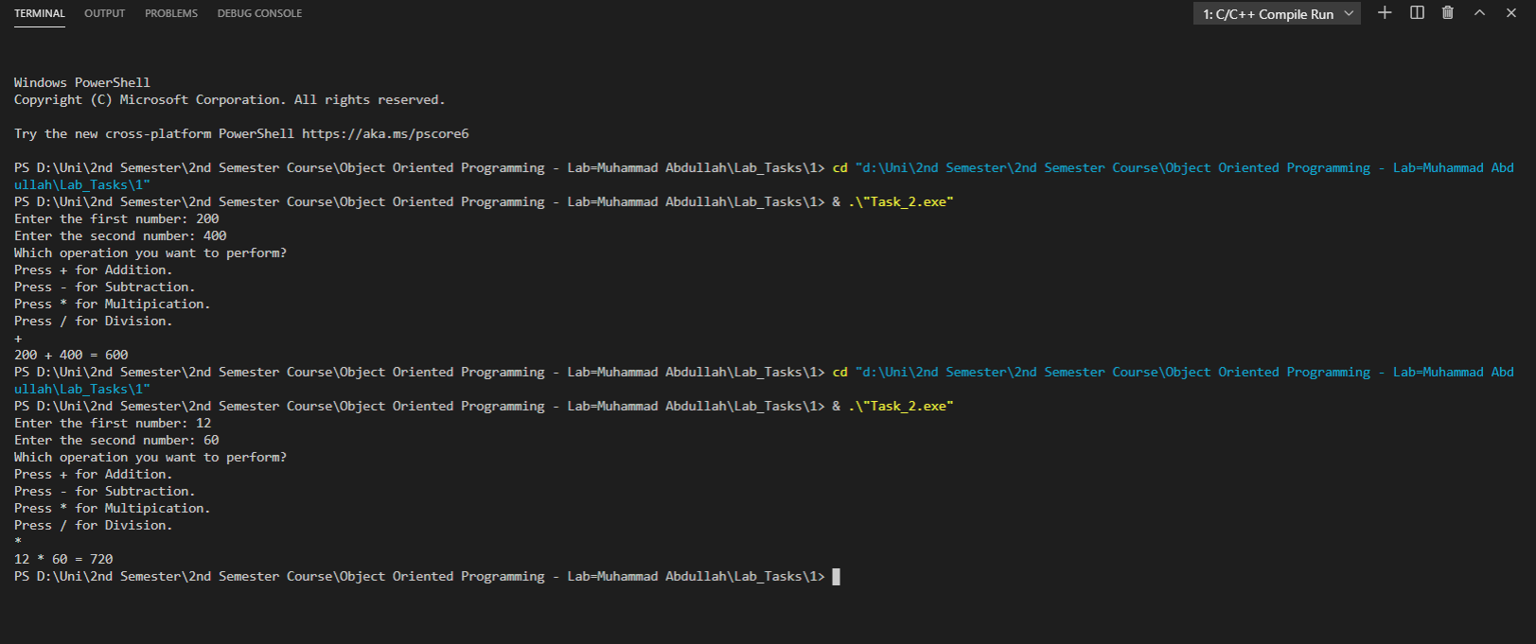

QNo.03: Problem –3 (Statement)

Write a program that takes grade as an input from the user and depending upon the grade display the message. Following is the criteria:

▪ If grade is 'A' then display “Excellent”

▪ If grade is 'B' then display “Very Good”

▪ If grade is 'C' then display “Good”

▪ If grade is 'D' then display “Poor”

▪ If grade is 'F' then display “Fail”

Note: use switch statement for solving this problem.

**Code:**

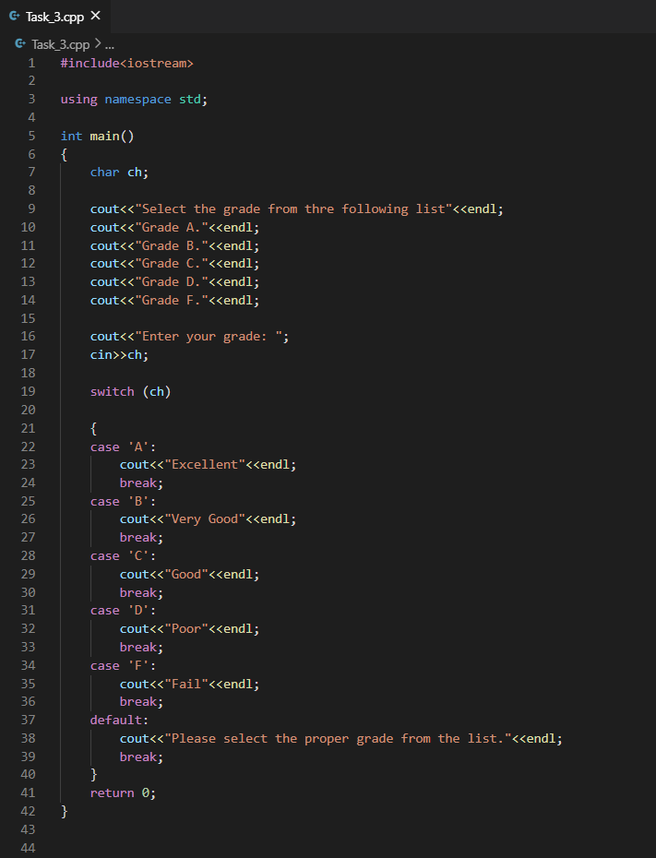

**Output:**

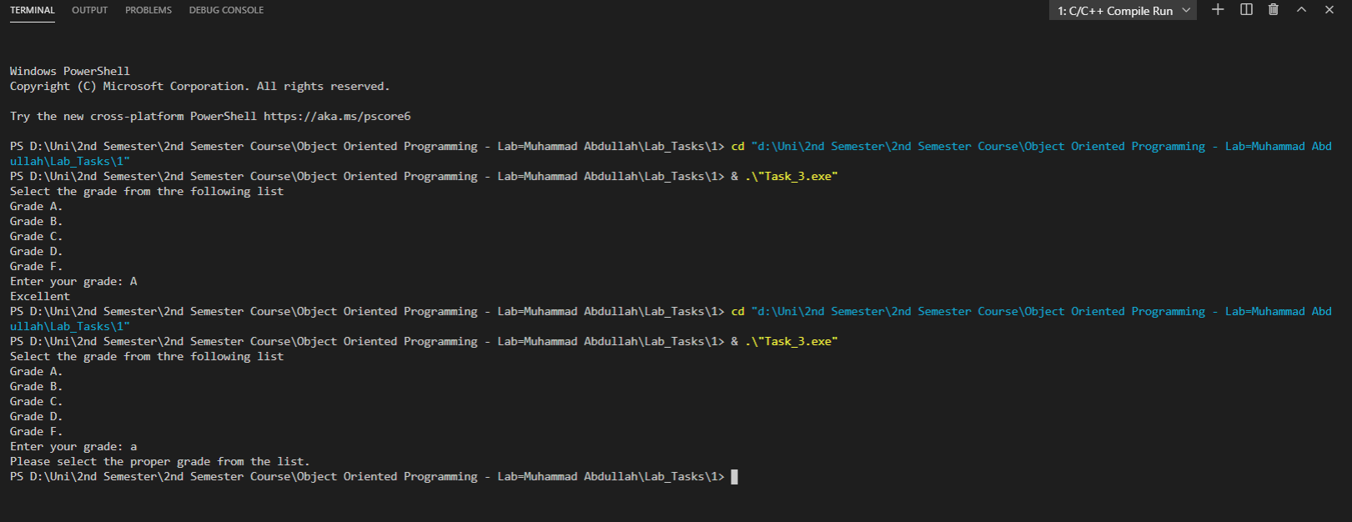

QNo.04: Problem –4 (Output)

Write a program that takes grade as an input from the user and depending upon the grade display the message. Following is the criteria:

▪ If grade is 'A' or 'a' then display “Excellent”

▪ If grade is 'B' or 'b' then display “Very Good”

▪ If grade is 'C' or 'c' then display “Good”

▪ If grade is 'D' or 'd' then display “Poor”

▪ If grade is 'F' or 'f' then display “Fail”

Note: use switch statement for solving this problem.

**Code:**

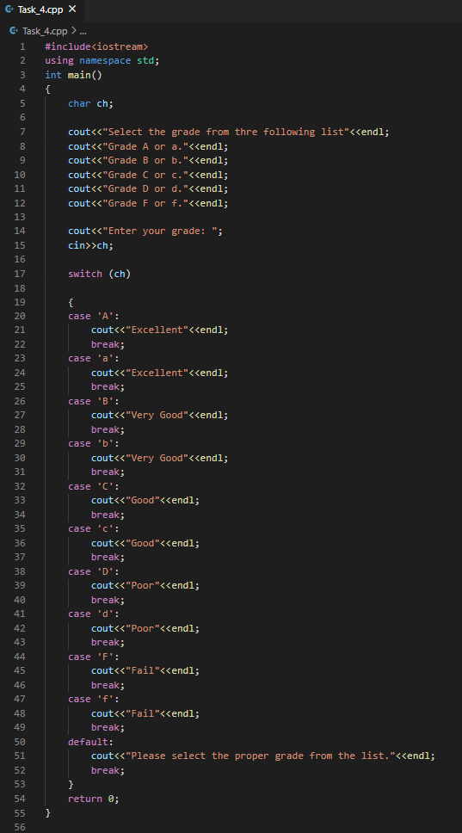

**Output:**

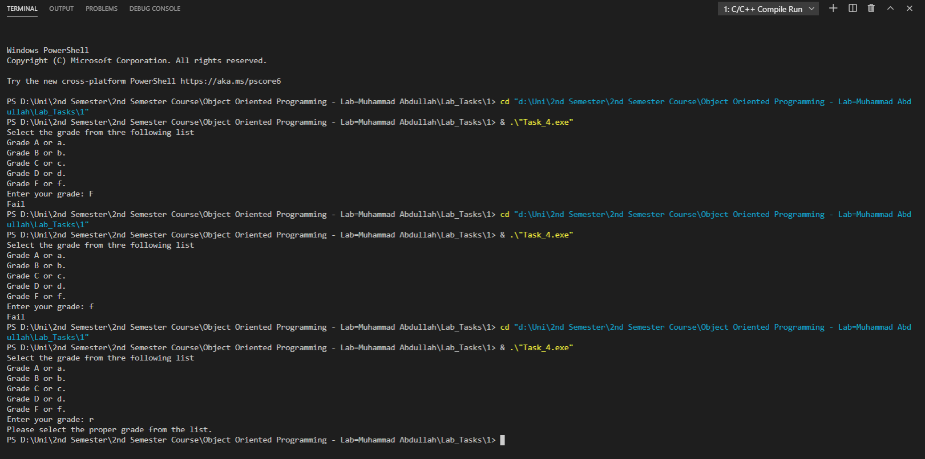

QNo.05: Problem –5 (Statement)

In a company, there are deductions from the salary of the employees for a fund. The deductions rules are as follows:

• If salary is less than Rs.10, 000 then no deduction

• If salary is equal to or more than Rs.10, 000 and less than Rs.20, 000 then deduct Rs.1, 000 as fund

• If salary is equal to or more than 20,000 then deduct 7 % of the salary for fund

Input salary from user and after appropriate deduction show the net payable amount.

**Code:**

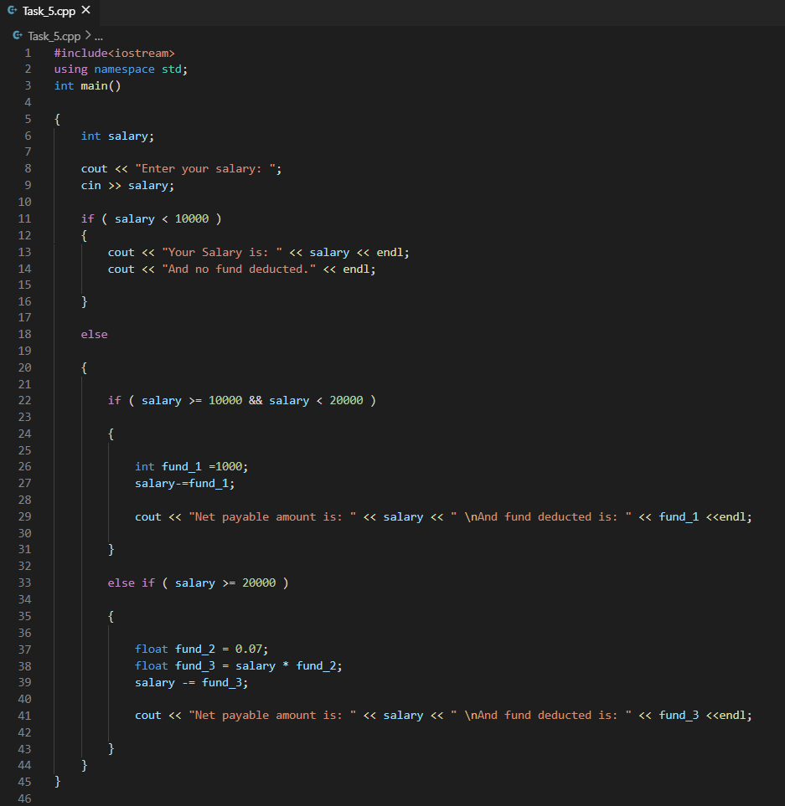

**Output:**

